PRACTICAL WEEK-10 Containerized Hosting & Orchestration [V.SATHVIK,2520090097]
WEEK-10
│
┌───────────────┼────────────────┐
↓ ↓ ↓
Docker Docker Compose Kubernetes
│ │ │ Containerize Run all services Run Gateway each service together with 2 replicas
│ │ │
└───────────────┴────────────────┘
↓
Kill one Pod
↓ Kubernetes replaces

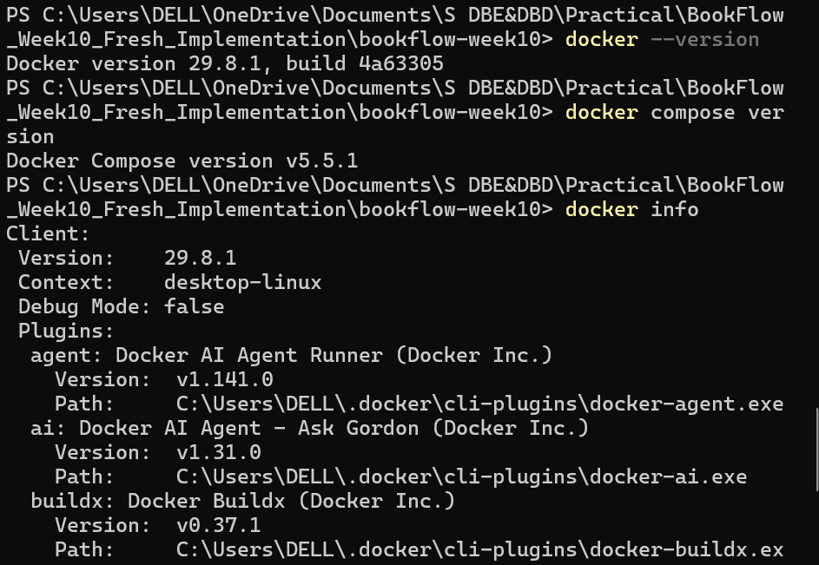

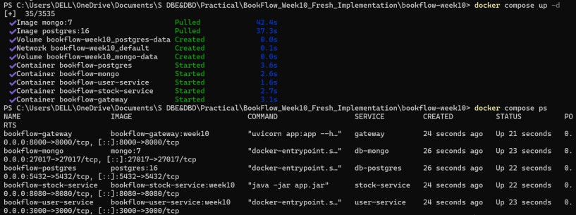
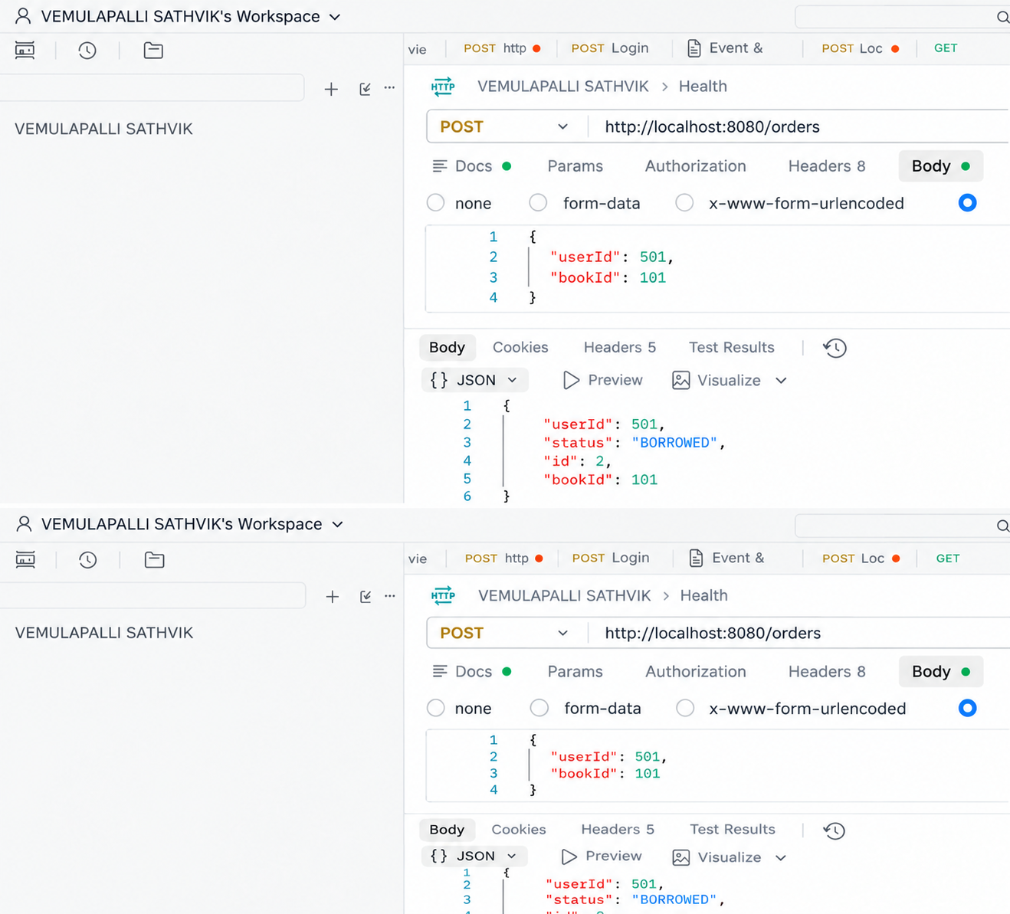
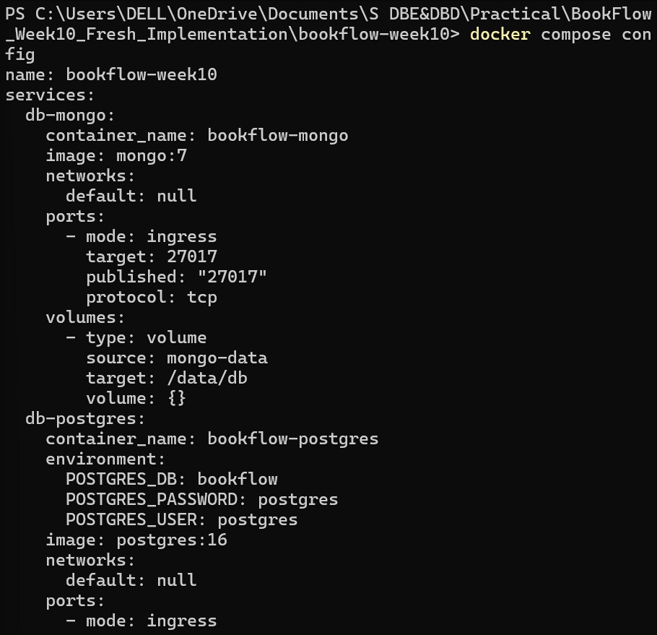

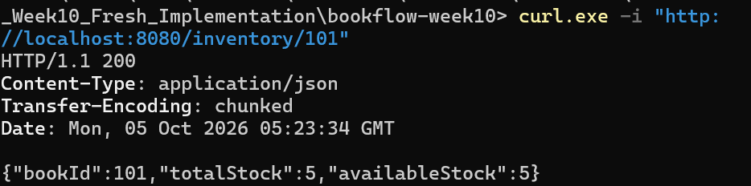

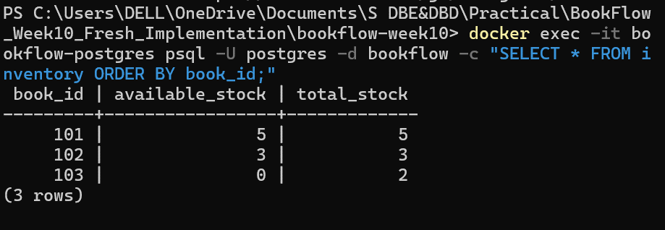

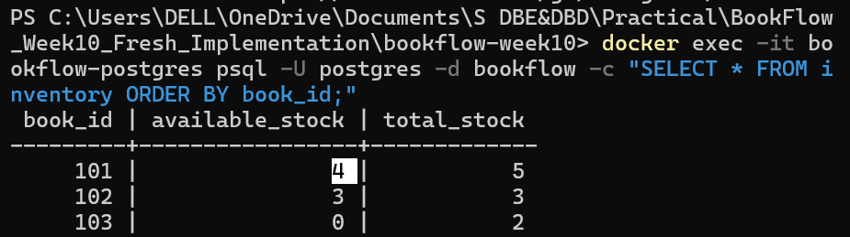

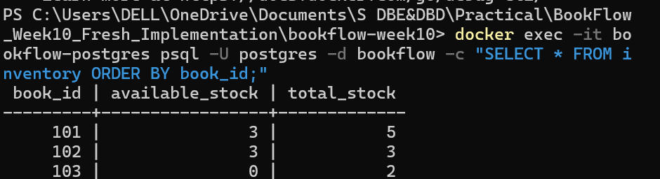

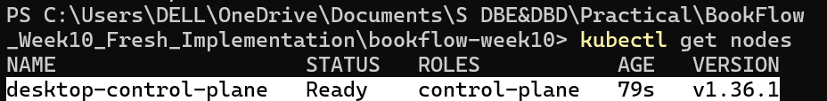

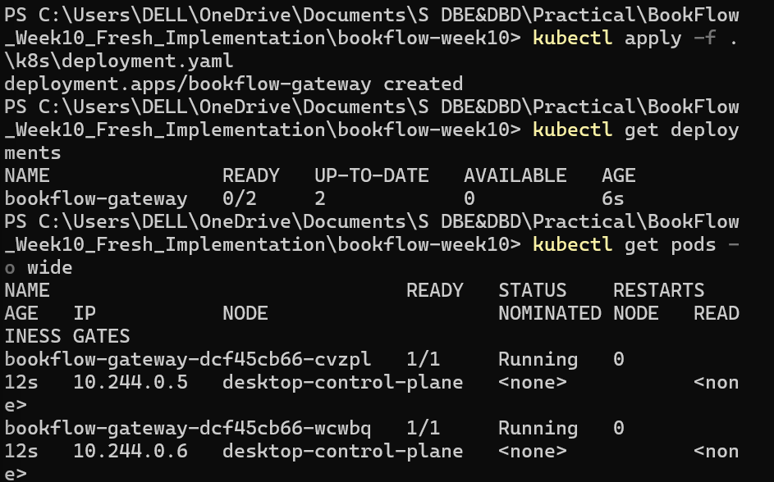

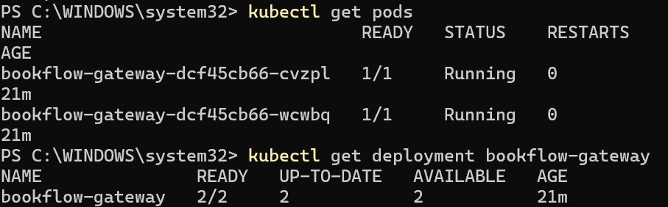

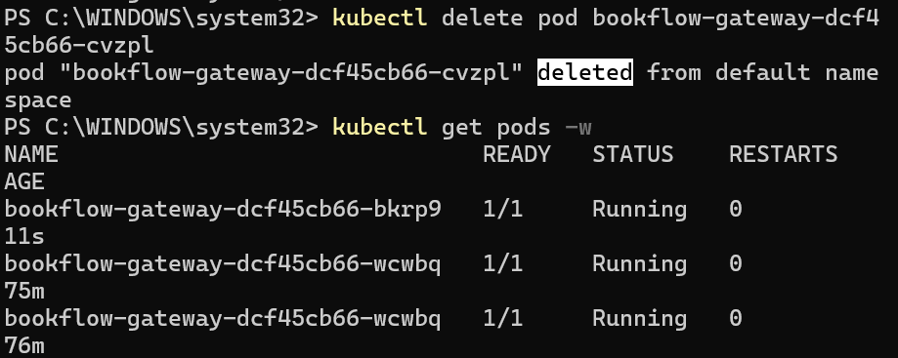

Folder Structure:
BookFlow_Week10_Fresh_Implementation/
└── bookflow-week10/
│
├── docker-compose.yml
├── README.md
│
├── gateway/
│ ├── Dockerfile
│ ├── requirements.txt
│ └── app.py
│
├── user-service/
│ ├── Dockerfile
│ ├── package.json
│ └── server.js
│
├── stock-service/
│ ├── Dockerfile
│ ├── pom.xml
│ └── src/
│ └── main/
│ ├── java/
│ │ └── com/bookflow/week10/
│ │ ├── StockServiceApplication.java
│ │ ├── controller/
│ │ │ └── StockController.java
│ │ ├── entity/
│ │ │ ├── Inventory.java
│ │ │ └── LibraryOrder.java
│ │ └── repository/
│ │ ├── InventoryRepository.java
│ │ └── LibraryOrderRepository.java
│ │
│ └── resources/
│ └── application.yml
│
└── k8s/
├── deployment.yaml
└── service.yaml

Codes:
- gateway/Dockerfile

FROM python:3.11-slim WORKDIR /app

COPY requirements.txt .
RUN pip install --no-cache-dir -r requirements.txt COPY app.py .
EXPOSE 8000
CMD ["uvicorn", "app:app", "--host", "0.0.0.0", "--port", "8000"]

- gateway/app.py

import os import httpx
from fastapi import FastAPI, HTTPException
app = FastAPI(title="BookFlow Gateway", version="Week-10", description="Containerized gateway by Vemulapalli Sathvik")
USER_SERVICE_URL = os.getenv("USER_SERVICE_URL", "http://localhost:3000") STOCK_SERVICE_URL = os.getenv("STOCK_SERVICE_URL", "http://localhost:8080") @app.get("/health")
async def health():
return {"service":"bookflow-gateway","week":"10","author":" Vemulapalli Sathvik ","status":"UP"}
@app.get("/gateway/users") async def get_users():
async with httpx.AsyncClient() as client:
r = await client.get(f"{USER_SERVICE_URL}/users")
if r.status_code >= 400: raise HTTPException(status_code=r.status_code, detail=r.text)
return r.json() @app.post("/gateway/orders")
async def create_order(order: dict):
async with httpx.AsyncClient() as client:
r = await client.post(f"{STOCK_SERVICE_URL}/orders", json=order) if r.status_code >= 400: raise HTTPException(status_code=r.status_code,
detail=r.text) return r.json()

- gateway/requirements.txt

fastapi==0.115.6 uvicorn[standard]==0.34.0 httpx==0.28.1
- user-service/Dockerfile

FROM node:18-alpine WORKDIR /app
COPY package*.json ./
RUN npm install --omit=dev COPY server.js .
EXPOSE 3000

CMD ["npm", "start"]
- user-service/server.js

const express = require('express'); const mongoose = require('mongoose');
const app = express(); app.use(express.json()); const PORT=3000,
MONGO_URL=process.env.MONGO_URL||'mongodb://localhost:27017/bookflow_users'; const User=mongoose.model('User',new mongoose.Schema({userId:{type:Number,unique:true},name:String,role:String})); app.get('/health',(req,res)=>res.json({service:'bookflow-user-service',week:'10',author:' Vemulapalli Sathvik,status:'UP'})); app.get('/users',async(req,res)=>res.json(await User.find().select('-_id -
v')));
app.post('/users',async(req,res)=>{const u=await User.create(req.body);res.status(201).json({userId:u.userId,name:u.name,role:u
.role});});
async function start(){try{await mongoose.connect(MONGO_URL);const e=await User.findOne({userId:501});if(!e)await User.create({userId:501,name:' Vemulapalli Sathvik ',role:'Student'});app.listen(PORT,'0.0.0.0',()=>console.log('User Service running on port 3000'));}catch(e){console.error(e.message);process.exit(1)}}
start();

- user-service/package.json

{"name":"bookflow-user-service","version":"1.0.0","main":"server.js","scripts":{"start":"node
server.js"},"dependencies":{"express":"4.21.2","mongoose":"8.9.5"}}

- stock-service/Dockerfile

FROM maven:3.9-eclipse-temurin-17 AS build WORKDIR /build
COPY pom.xml . COPY src ./src
RUN mvn clean package -DskipTests FROM eclipse-temurin:17-jre WORKDIR /app
COPY --from=build /build/target/bookflow-stock-service-1.0.0.jar app.jar EXPOSE 8080
ENTRYPOINT ["java","-jar","app.jar"]

- stock-service/pom.xml

<?xml version="1.0" encoding="UTF-8"?><project xmlns="http://maven.apache.org/POM/4.0.0" xmlns:xsi="http://www.w3.org/2001/XMLSchema-instance"

xsi:schemaLocation="http://maven.apache.org/POM/4.0.0 https://maven.apache.org/xsd/maven-4.0.0.xsd"><modelVersion>4.0.0</modelVersion><parent><groupId>org.springframew ork.boot</groupId><artifactId>spring-boot-starter-parent</artifactId><version>3.5.5</version><relativePath/></parent><groupId>co m.bookflow.week10</groupId><artifactId>bookflow-stock-service</artifactId><version>1.0.0</version><properties><java.version>17</java
.version></properties><dependencies><dependency><groupId>org.springframework.b oot</groupId><artifactId>spring-boot-starter-web</artifactId></dependency><dependency><groupId>org.springframework.boot</gr oupId><artifactId>spring-boot-starter-data-jpa</artifactId></dependency><dependency><groupId>org.postgresql</groupId><art ifactId>postgresql</artifactId><scope>runtime</scope></dependency></dependenci es><build><plugins><plugin><groupId>org.springframework.boot</groupId><artifac tId>spring-boot-maven-plugin</artifactId></plugin></plugins></build></project>
- stock-service/src/main/java/com/bookflow/week10/StockServiceApplication.java

package com.bookflow.week10;
import org.springframework.boot.SpringApplication;
import org.springframework.boot.autoconfigure.SpringBootApplication; @SpringBootApplication
public class StockServiceApplication { public static void main(String[] args){SpringApplication.run(StockServiceApplication.class,args);} }
- stock-service/src/main/java/com/bookflow/week10/controller/StockController.java

package com.bookflow.week10.controller;
import com.bookflow.week10.entity.*; import com.bookflow.week10.repository.*; import org.springframework.http.ResponseEntity; import org.springframework.web.bind.annotation.*; import java.util.Map; @RestController public class StockController { private final InventoryRepository inventory; private final LibraryOrderRepository orders; public StockController(InventoryRepository i,LibraryOrderRepository o){inventory=i;orders=o;}
@GetMapping("/health") public Map<String,String> health(){return Map.of("service","bookflow-stock-service","week","10","author"," Vemulapalli Sathvik ","status","UP");}
@GetMapping("/inventory/{bookId}") public ResponseEntity<?> get(@PathVariable Long bookId){return inventory.findById(bookId).map(ResponseEntity::ok).orElse(ResponseEntity.notFo und().build());}
@PostMapping("/orders") public ResponseEntity<?> order(@RequestBody Map<String,Long> req){Long u=req.get("userId"),b=req.get("bookId"); Inventory i=inventory.findById(b).orElse(null); if(i==null)return ResponseEntity.notFound().build(); if(i.getAvailableStock()<=0)return ResponseEntity.status(409).body(Map.of("status",409,"error","OUT_OF_STOCK","me

ssage","Book "+b+" is out of stock")); i.setAvailableStock(i.getAvailableStock()-1);inventory.save(i);LibraryOrder o=orders.save(new LibraryOrder(u,b,"BORROWED"));return ResponseEntity.status(201).body(Map.of("id",o.getId(),"userId",o.getUserId()," bookId",o.getBookId(),"status",o.getStatus()));}}
- stock-service/src/main/java/com/bookflow/week10/entity/Inventory.java

package com.bookflow.week10.entity; import jakarta.persistence.*; @Entity @Table(name="inventory")
public class Inventory { @Id private Long bookId; private Integer totalStock; private Integer availableStock; public Inventory(){} public Inventory(Long id,Integer total,Integer available){bookId=id;totalStock=total;availableStock=available;} public Long getBookId(){return bookId;} public void setBookId(Long v){bookId=v;} public Integer getTotalStock(){return totalStock;} public void setTotalStock(Integer v){totalStock=v;} public Integer getAvailableStock(){return availableStock;} public void setAvailableStock(Integer v){availableStock=v;} }
- stock-service/src/main/java/com/bookflow/week10/entity/LibraryOrder.java

package com.bookflow.week10.entity; import jakarta.persistence.*; @Entity @Table(name="orders") public class LibraryOrder { @Id
@GeneratedValue(strategy=GenerationType.IDENTITY) private Long id; private Long userId; private Long bookId; private String status; public LibraryOrder(){} public LibraryOrder(Long u,Long b,String s){userId=u;bookId=b;status=s;} public Long getId(){return id;} public Long getUserId(){return userId;} public Long getBookId(){return bookId;} public String getStatus(){return status;} }
- stock-service/src/main/java/com/bookflow/week10/repository/InventoryRepository.ja va

package com.bookflow.week10.repository;
import com.bookflow.week10.entity.Inventory; import org.springframework.data.jpa.repository.JpaRepository;
public interface InventoryRepository extends JpaRepository<Inventory,Long>{}

- stock-service/src/main/java/com/bookflow/week10/repository/LibraryOrderRepository
.java

package com.bookflow.week10.repository;
import com.bookflow.week10.entity.LibraryOrder; import org.springframework.data.jpa.repository.JpaRepository;

public interface LibraryOrderRepository extends JpaRepository<LibraryOrder,Long>{}

- stock-service/src/main/resources/application.yml

spring: datasource:
url: ${DB_URL:jdbc:postgresql://localhost:5432/bookflow} username: ${DB_USERNAME:postgres}
password: ${DB_PASSWORD:postgres} jpa:
hibernate:
ddl-auto: update show-sql: true
server: port: 8080
- docker-compose.yml

services: gateway:
build: ./gateway
image: bookflow-gateway:week10 container_name: bookflow-gateway ports: ["8000:8000"]
environment:
USER_SERVICE_URL: http://user-service:3000 STOCK_SERVICE_URL: http://stock-service:8080
depends_on: [user-service, stock-service] user-service:
build: ./user-service
image: bookflow-user-service:week10 container_name: bookflow-user-service ports: ["3000:3000"]
environment:
MONGO_URL: mongodb://db-mongo:27017/bookflow_users depends_on: [db-mongo]
stock-service:
build: ./stock-service
image: bookflow-stock-service:week10 container_name: bookflow-stock-service ports: ["8080:8080"]
environment:
DB_URL: jdbc:postgresql://db-postgres:5432/bookflow DB_USERNAME: postgres
DB_PASSWORD: postgres depends_on: [db-postgres]
db-postgres:

image: postgres:16 container_name: bookflow-postgres environment:
POSTGRES_DB: bookflow POSTGRES_USER: postgres POSTGRES_PASSWORD: postgres
ports: ["5432:5432"]
volumes: [postgres-data:/var/lib/postgresql/data] db-mongo:
image: mongo:7
container_name: bookflow-mongo ports: ["27017:27017"]
volumes: [mongo-data:/data/db] volumes:
postgres-data:
mongo-data:

- k8s/deployment.yaml

apiVersion: apps/v1 kind: Deployment metadata:
name: bookflow-gateway labels:
app: bookflow-gateway owner: Vemulapalli Sathvik
spec:
replicas: 2 selector:
matchLabels:
app: bookflow-gateway template:
metadata: labels:
app: bookflow-gateway owner: Vemulapalli Sathvik
spec:
containers:
- name: gateway
image: bookflow-gateway:week10 imagePullPolicy: IfNotPresent ports:
- containerPort: 8000

- k8s/service.yaml
apiVersion: v1 kind: Service metadata:

name: bookflow-gateway-service labels:
app: bookflow-gateway owner: Vemulapalli Sathvik
spec:
type: LoadBalancer selector:
app: bookflow-gateway ports:
- protocol: TCP port: 8000
targetPort: 8000
